The Final Adjustments and Fixes

Overall:

1. THE DELAY BEFORE THE WHEEL DISAPPEARS NEEDS TO BE LONGER.

* DONE Instead, make it so that wheel remembers locked-in notes upon reentering wheel.

2. NO USE OF COLORS ON NON-INTERACTIVE STUFF: ELEVATOR TORCHES, ELEVATOR BARRIERS, BANK BOX, ETC.

3. COLOR ON WHEEL NEED TO BE REARRANGED FOR GREATER CLARITY.

* Moving red / green and moving yellow / orange

4. PIZZA SLICES NEED TO BE MORE EASILY VISIBLE, NAMELY ON EAST WING PLATFORMS.

5. BALLS IN WEST WING RUIN LIVES AND BREAK GAMES.

Additionally

* Implement and test out UI directional auras
* Change light to small circle shape and make sure it blends into environment
* 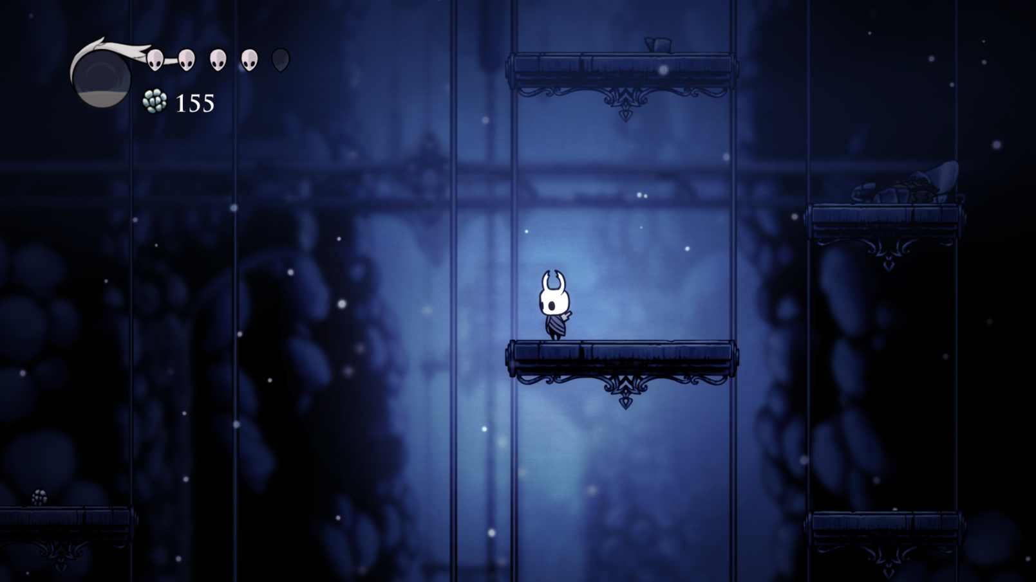
* Fix delay in tones
* Add remaining sounds and adjust for juice
* Fix door collider on all doors
* Make finished wings be blocked by a door.
* need to fix tile platform conflict.

Tutorial

* Make torches colorless
* Make torches look like torches: it looks like a lot of blood

Bell rooms

* Remove hint after bell is rung. - remove all hints that can’t be interacted with
* Fix ledge hopping over in all bell rooms

West wing

* Readjust camera in all rooms
  + zoom less out, resize collision box
* Fix ball falling out of bounds in W3 and W4
  + Make platforms either be BIG blocks, or make reset zones for the balls
  + Try slopes instead of stairs
  + Redraw, some tiles are bad
  + In W3:
    - Create big blocks to avoid ball going in pit
  + In W4:
    - Platform on left needs an opposite stair tile for ball to get out
    - Platform on right needs to stop at position so ball cannot fall down
* Fix from pressure to directional in W3
  + already done
* Make all puzzles with balls use the directional mechanic.
* attach auras to balls themselves.

East wing

* Add UI arrows for drawbridge in E1
* Adjust pump wagon in all rooms with tracks, headlights, sound effect on switching direction. Overcome difficulty with not knowing when it stops
* Make wheel on pump wagons be readable - fx when camera pans out or notewheel obscures view
* In E3 make sure that you don’t fall down and restart the whole room. Adjust last wagon to be more affordable
  + Minimize gap in 2nd wagon path
* DONE In E5 make lights colourless
* In E5 place lights outside wheel
* DONE Remove E8
* Make drawbridge stop playing sound when position is locked.
  + Need to move the play sound effect into the rotation actions instead of in the “wheelRotateActivator”
* Make drawbridge play locking in place sound when hitting final angle. Locking in place sound also play for when lock combination resets

Bottom

* Move first torch before the door
* Remove / change the coloured torches in final room

Tiles:

* Make the tile for tracks going up be narrower.
* Lock combination: make new sprite resembling breaking into safe
* Change tile colliders to grid and slopes
* Fix sliding on stairs